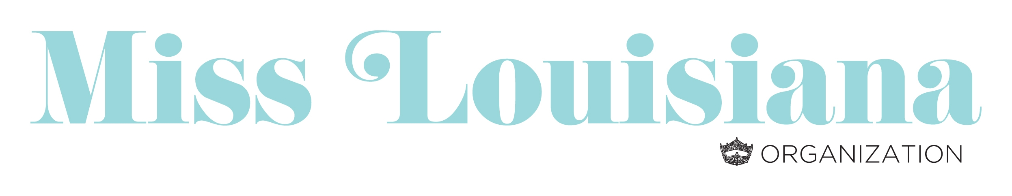
Instructions for Ad Pages

- All MLO Contestants are required to sell a minimum of 2 Full ad pages for the MLO program book. (Ad pages are 8 ½ x 11.)
  - ALL money and advertisements are due at State Meeting registration on April 6, 2019.
  - Place all ads, a flash drive of pictures, Ad Sales Agreements and other information in a manila envelope labeled with contestant’s name and title.

- Partial pages cannot be accepted. For Example: If you sell a ½ page ad to one business, a ¼ page ad to another, then you must have another ¼ page or 2–1/8 page ads to make up a full page. You will be financially responsible for the unsold portion of an ad page.

Ad Pricing: Full Page: $360
Half Page: $180
1/4 Page: $90
1/8 Page: $45

- Attached is a copy of the Ad Sales Agreement and Contestant Information Form. You will need to:
  - Give a copy of the Agreement to the person to whom you are selling the ad.
  - Make a copy to turn in with your ads.
  - Email Information Form to jamie.hilburn11@gmail.com by April 6.

- Personal Checks will not be accepted.
  - A business check made payable to the Miss Louisiana Organization will be accepted.
  - Monies collected other than business checks must be submitted as one certified check or one money order for the total amount of pages sold.
  - All Payments must be submitted to the Miss Louisiana Organization at State Meeting registration on April 6.

- Only digital pictures and graphics on a flash drive will be accepted for ads.
  - Business cards submitted as an ad must be scanned into an electronic format to be accepted.

- All digital files (photos) for ad pages should have a minimum resolution of 300 dpi. Black and white photos are preferred. We cannot guarantee the quality of photos submitted from cell phones.
  - Acceptable file formats include: .jep, .tif, .eps, .gif, .psd, .pdf, .jpg

- Contestants are not allowed to use the CMNH, Miss America, or Miss Louisiana Organization logos.

*Please check your flash drive to make sure that all information is uploaded.

