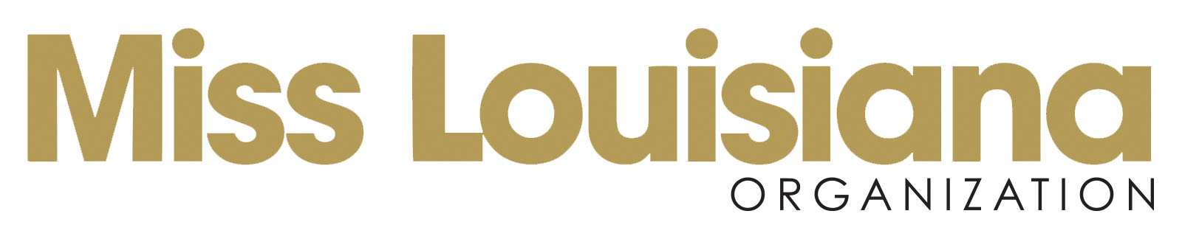
General Instructions for Ad Pages

- The Miss Louisiana Organization encourages each MISS candidate to sell a minimum of 2 FULL ad pages for the program book.
  - Ads and payments are due at state meeting on April 4. NO exceptions.
  - Please place all ads, pictures, flash drive and any additional information in a large white envelope labeled with contestant’s name and title.

- Partial ad pages will not be accepted. If the sum of a contestant’s ads does not take up an entire page then the contestant will be financially responsible for the remainder of the page at state meeting.

- A program book contract is provided that can be given to the buyer at the time of purchase. This contract will serve as a receipt to the purchaser. You must turn in a copy of the contract for each ad sold to ensure that all your ads will be included in the book. Every ad should have a contract page turned in with money. A W-9 can be provided if needed.

- Personal Checks will NOT be accepted.
  - A company check made payable to the Miss Louisiana Organization will be accepted for business ads.
  - Monies collected other than company checks must be submitted as ONE CERTIFIED CHECK or MONEY ORDER for the TOTAL AMOUNT of pages sold.
  - All Payments must be submitted at State Meeting.

- Keep text to a minimum on small ads.
  - LESS is best.
  - 2 or 3 legible lines of type and a logo are much more effective than a logo and 10 lines of type crammed into a small space

- Please remember that ONLY digital pictures on a flash drive will be accepted for ads.
  - Business cards must be scanned into an electronic format to be accepted. We cannot accept paper business cards.

- All digital files for ad pages should have a minimum resolution of 210 dpi.
  - Acceptable file formats include: .jep, .tif, .eps, .gif, .psd, .pdf, .jpg

- Contestants are NOT allowed to use the CMNH, Miss America, or Miss Louisiana logos in their ads.

**Check your flash drive to make sure that all information is included.

I, ______________________________________________ (contestant name),

agree to provide the following ad in the
Miss Louisiana Scholarship Organization’s 2020 Program Book on behalf of

__________________________________________________ (purchaser of the ad).

Please circle ad page sold:
Full Page $360.00
1/2 Page $180.00
1/4 Page $90.00
1/8 Page (Business Card) $45.00

Details of Ad Sold or Print to be added to page:

____________________________________________________________________________

____________________________________________________________________________

____________________________________________________________________________

Thank you for your support of the Miss Louisiana Scholarship Organization.

___________________________________ _________________________________
(Ad Seller) (Ad Purchaser)

